Prompts:

1. Explain step-by-step what happens to the data in this pipeline." ps aux | grep 'bash' | wc -lWhat is the standard input and standard output for each command in that pipeline?
2. Can you visualize the data flow for cat data.log | sort | uniq?
3. What are common mistakes when creating Bash pipelines?

Results:

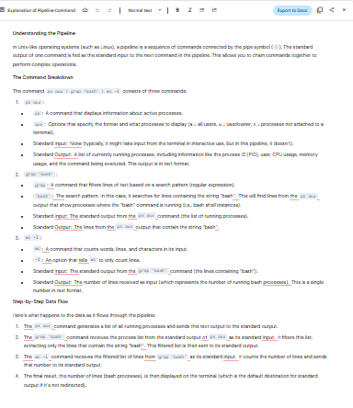

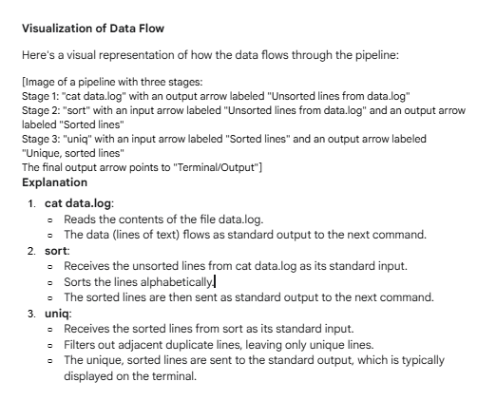

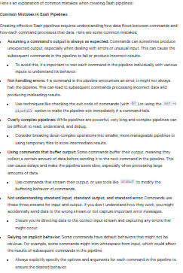

**Learning Process for Bash Pipelines**

Based on the information, here's a breakdown of the key steps and concepts involved in learning about Bash pipelines:

1. **Understanding the Basics:**
   * A pipeline is a sequence of commands.
   * Commands are connected by the pipe symbol (|).
   * The standard output of one command is fed as standard input to the next command.
2. **Key Concepts:**
   * **Standard Input:** The stream of data that a command reads.
   * **Standard Output:** The stream of data that a command produces.
   * Commands are chained together to perform complex operations.

Bash pipelines are centrally an algorithmic structure of linear computation architectures.